# C951 Task 1: Pandorabots Chatbot

James Thomason

10/28/2024

**Section A: Chatbot Functionalities**

The WGU Computer Science chatbot is designed to direct students into different careers depending on their personalities and personal strengths. The chatbot has two different options that the user may choose from. The first option is a list of 5 different high paying careers for computer science graduates. The second is a series of questions that the student must answer. Each question has two answers and no more than three questions are asked before presenting the student with a potential career path.

**Section B: Computer Science Career Choices**

The WGU Career chatbot has two sections and identifies a total of 11 career choices. Some careers are used in both sections.

* Machine Learning Engineer
* Data Scientist
* Software Architect
* Software Engineer
* Cybersecurity Engineer
* Mobile Developer
* Web Developer
* Big Data Engineer
* Cloud Architect
* Network Architect
* Information Security Engineer

**Section C: Code File**

The AIML code is in the attached file ‘C951JamesThomason.zip’.

**Section D: Training Cases**

The first section simply provides a list of careers to choose from that are high paying. The second section starts with a beginning question and presents another question depending on how they answered. It functions very much like a binary tree - each question has two answers. Below are the career choices used in the second section and the answers required for that career to be presented at the end of the questionnaire. The career is considered the training case and each answer indicates their preference in a certain topic.

1. Mobile Developer
   1. Software
   2. Applications
   3. Mobile
2. Web Developer
   1. Software
   2. Applications
   3. Web
3. Data Scientist
   1. Software
   2. Data
   3. Algorithms
4. Big Data Engineer
   1. Software
   2. Data
   3. Large Scale Systems
5. Cloud Architect
   1. Infrastructure
   2. Networks
   3. Cloud Infrastructure
6. Network Architect
   1. Infrastructure
   2. Networks
   3. Network Infrastructure
7. Cybersecurity Engineer
   1. Infrastructure
   2. Cybersecurity
   3. Engineering
8. Information Security Engineer
   1. Infrastructure
   2. Cybersecurity
   3. Implementing

In order to keep the chatbot simple, I used the AIML to use buttons for the answer choices instead of having students type in their answer. This allows for ease of use and to prevent students from giving answers that the chatbot is not trained to respond to. I also used a wildcard (*) at the beginning of the chat. This allows a standard message to be shown for any input that the chatbot isn’t trained for.

**Section E: Installation Guide**

* Go to Pandorabots.com
* Login to your account or sign up for a free account
* On the left hand side bar, click on ‘Directory’ or go to https://home.pandorabots.com/dash/bot-directory
* In the search bar, type ‘wguC951JamesT’ and hit enter
* In the search results, you will see the bot listed as ‘wguC951JamesT’. Click on this bot and it will start the chat bot automatically.
* In the chatbot window, type ‘hello’.

Use the image below as a visual reference:

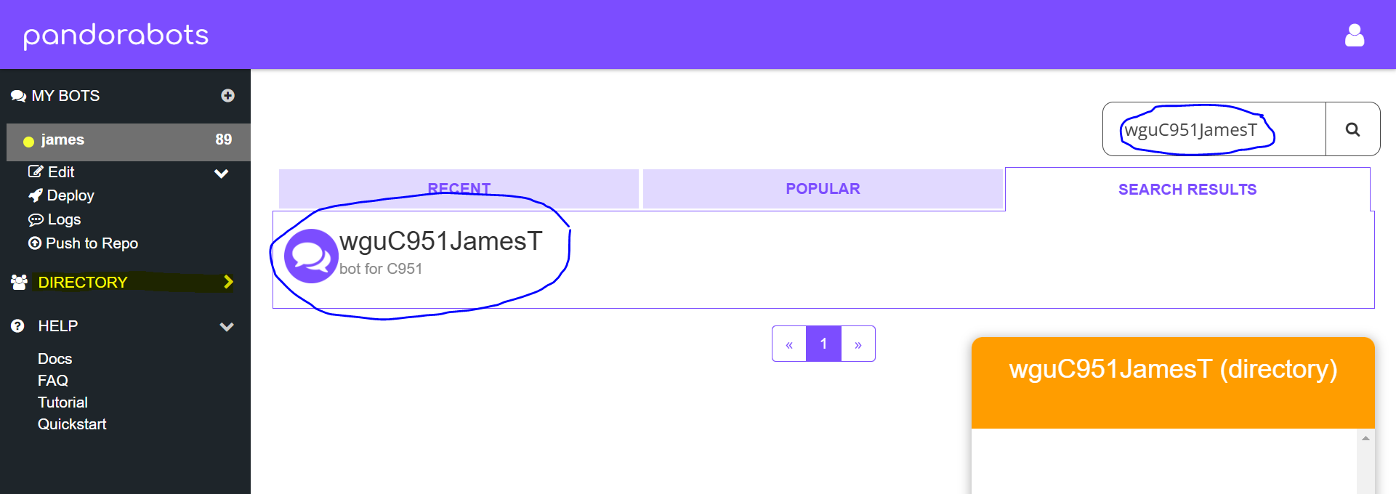

**Section F: Chatbot Development**

AIML was an easy to use language and I was able to learn the basics within a couple hours. This made it possible to build a basic functioning chatbot in less than a day. Another strength was the ease of deployment. I was able to use their internal directory which makes it easy to share with others.

Although it was easy to learn the basics, there is a lot of advanced functionality that requires more learning. If you are building an advanced chatbot, you may have to spend a lot of time learning these advanced features. Another weakness is since you have to consider every input option a student might have, you may have to come up with different algorithms to make the chatbot functional, unless you use buttons as your user input.

**Section G: Monitoring**

This chatbot is a very basic version that can be expanded upon in the future. More careers and questions can be added to further refine career options for the student. The chatbot currently uses buttons to answer questions, but in the future, the chatbot could be trained to take typed answers directly from the student. This would require further development and training of the chatbot. Maintenance should be conducted quarterly to ensure that information and data are correct.

**Section H: Panopto Recording**

The following is a link to a Panopto recording: <https://wgu.hosted.panopto.com/Panopto/Pages/Viewer.aspx?id=de837cdf-2ff4-4e10-b116-b2170100015e>

In it, I give a description of the chatbot and give a rundown of the chatbot’s features.

**Section I: Sources**

No sources were used in this document.